**Dimensions Vs Measures**

* Dimensions contain qualitative values (such as names, dates, or geographic data).
* Measurements contain numerical, quantitative values that you can measure. Measures can be aggregated.

**Discrete Vs Continuous**

* Tableau represents data differently in visualization, depending on the type of discrete (blue) or continuous (green) field.
* Continuous and discrete are mathematical terms.
* Continuous means “the formation of an uninterrupted, uninterrupted whole”; discrete means “separate and distinct individual.”

**Examples of continuous and discrete fields-**

1. **Continuous-**
   * + In the line chart example, the Quantity field is set to Continuous, which creates a horizontal axis at the bottom of the view.
     + The green background and the axis help you see that it is a continuous field.

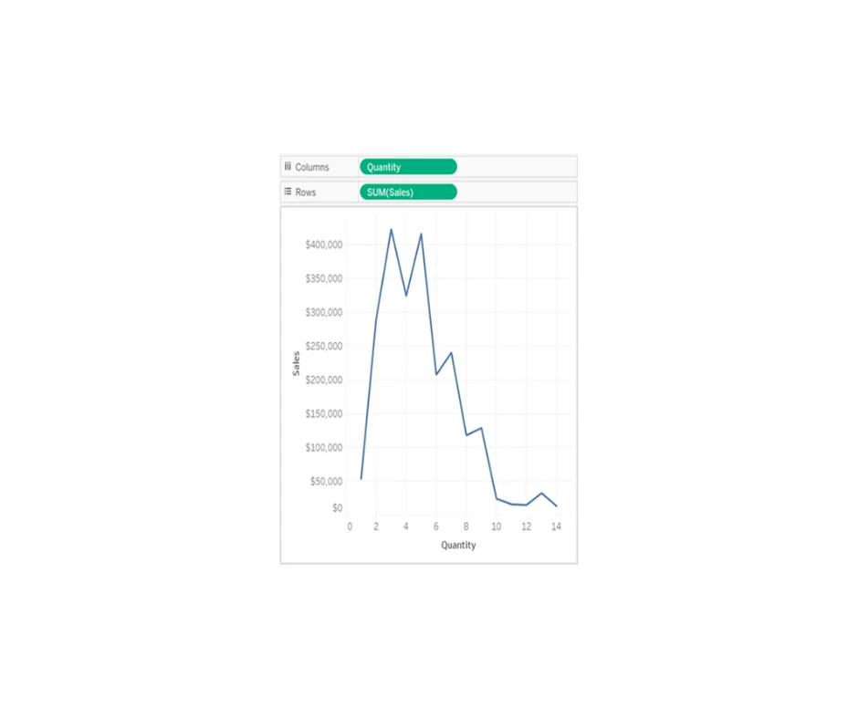

**2.Discrete-**

* + - In the bar chart example, the Quantity field has been set to Discrete.
    - It creates horizontal headers instead of an axis.
    - The blue background and horizontal headers help you see that it is discreet.

